
PYTHON PROGRAMMING LAB FILE

Name: Yogesh Dinesh joshi
Sap ID: 590025632
Batch: 34
Teacher: Sugandha Sharma

EXPERIMENT – 7
Objective 1:(a) Count Number of Names
Code:
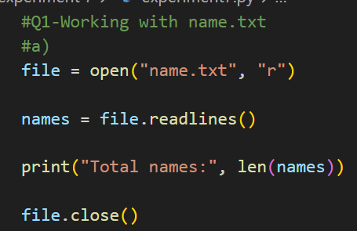
Output:
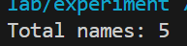
Objective 1: (b) Count Names Starting with Vowel
Code:
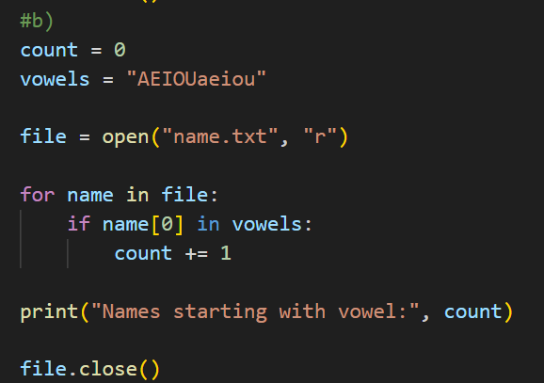
Output:
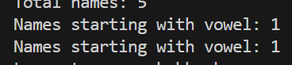

Objective: (c) Find Longest Name
Code:
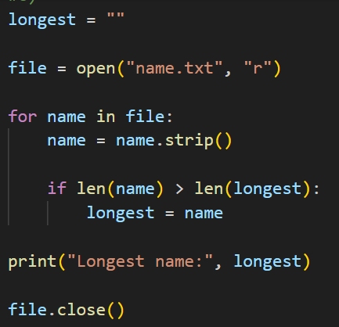
Output:


Objective 2: Store Integer in a file then,
- Find Maximum Number
- Find average
- Count number greater than 100
Code:
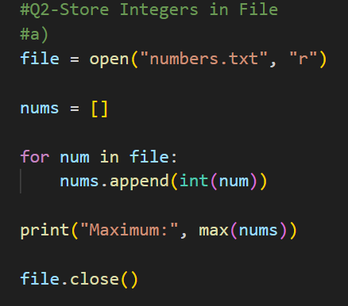
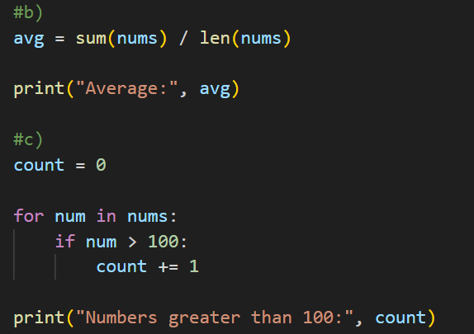

Output:
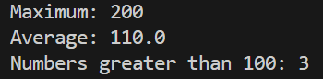

Objective 3: (a)Display All City Details
Code:
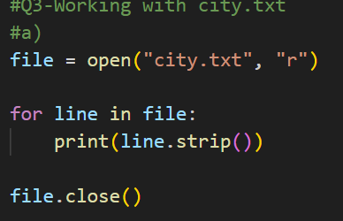
Output:
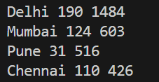
Objective 3: (b) Cities with Population > 10 Lakhs
Code:
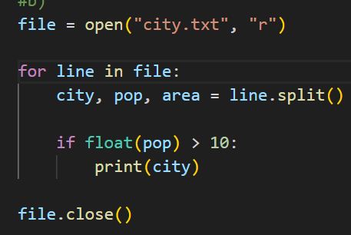
Output:
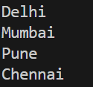

Objective 3: (c) Sum of Areas
Code:
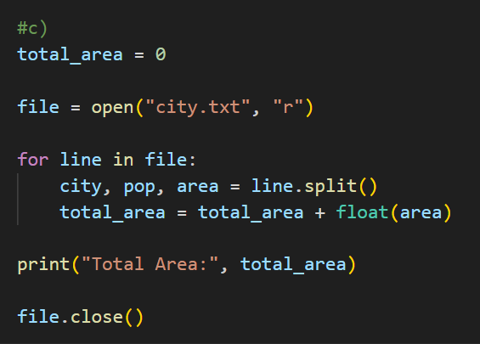
Output:


